**27**

**Direct-Current Circuits**

|  |
| --- |
| **CHAPTER OUTLINE** |

27.1 Electromotive Force

27.2 Resistors in Series and Parallel

27.3 Kirchhoff’s Rules

27.4 RC Circuits

27.5 Household Wiring and Electrical Safety

* An asterisk indicates a question or problem new to this edition.

|  |
| --- |
| **ANSWERS TO THINK–PAIR–SHARE PROBLEMS** |

**\*TP27.1 Conceptualize** By measuring the voltage across each component and knowing the current, we can determine the resistance of each element. We can then compare that resistance to the expected value to determine which component is defective.

**Categorize** This problem involves the use of Equation 26.7 for various circuit elements, as well as the application of Kirchhoff’s loop rule.

**Analyze** We have the upper limits for the operating resistance of the buzzer and the internal resistance in the battery:



Use Equation 26.10 to find the expected resistances of the two wires:





Now, use the measurements to evaluate the actual resistance of each component for which we have measured a voltage:







These values are all consistent with what we found online and the resistance of wire 2 from Equation 26.10. But what about wire 1?

We didn’t measure the voltage across wire 1. But we can use Kirchhoff’s loop rule to find that voltage, since all of the voltages must add to zero around the loop:



Substitute the voltages, keeping mind that the voltage drops across resistors:



This voltage is negative because it is a voltage drop across the resistance of wire 2. Take the magnitude of the voltage to find the resistance using Equation 26.7:



This resistance is much larger than the expected calculated resistance of 0.087 . Therefore, the defective component is wire 1.

**Finalize** This result suggests that perhaps a connection between the wire and the alligator clip is faulty and is creating more resistance than it should.

*Answer:* wire 1

**\*TP27.2 Conceptualize** Ideally, your supply would contain many values of resistance, so you could simply choose the appropriate single resistor for your need. Your situation is not ideal, however, so you must create particular values of resistance from your two available values.

**Categorize** This problem involves series and parallel combinations of resistors.

**Analyze** Notice that both groups in part (a) require a total resistance that is between the available resistances of 20  and 50 . It is helpful to evaluate combinations of the available resistances. A series combination increases the overall resistance and a parallel combination reduces it. Consider the following combinations:

(1) 20  and 20  in series: 40 

(2) 20  and 20  in parallel: 10 

(3) 50  and 50  in series: 100 

(4) 50  and 50  in parallel: 25 

(a) Group (i): For 45 , we can add 25  (combination 4) and 20  (available). To add resistances, the resistors must be in series, so

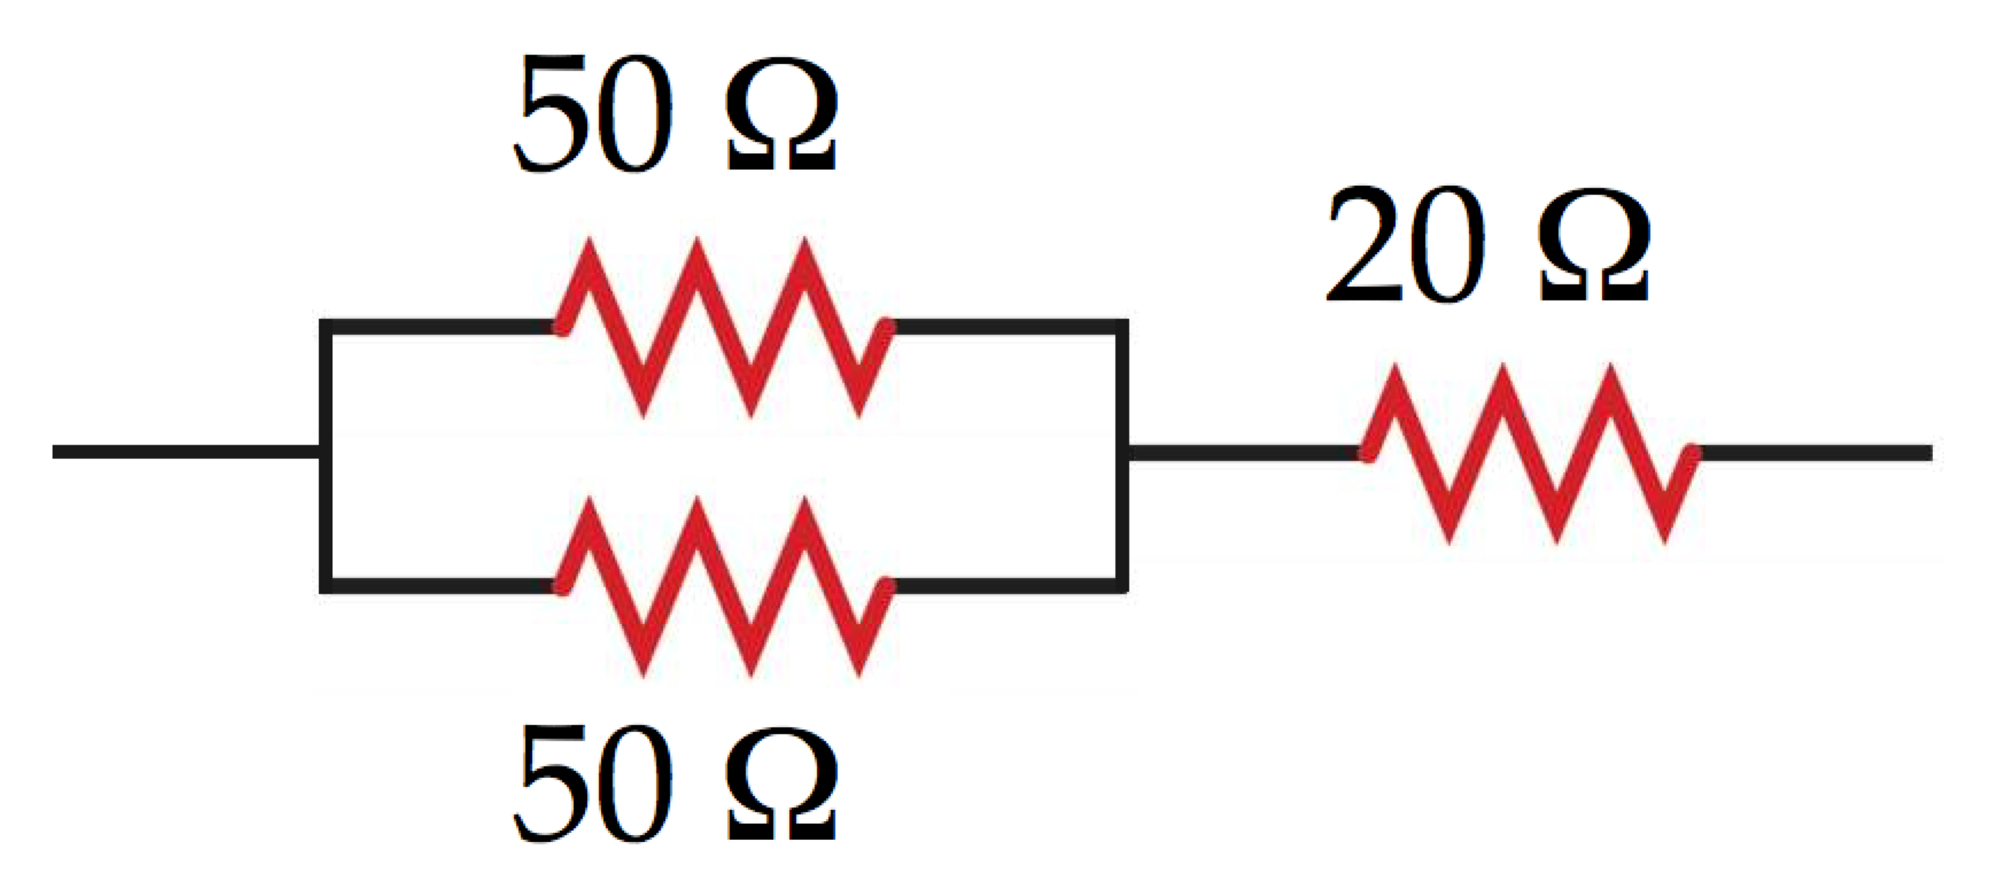

Group (ii): For 35 , we can add 25  (combination 4) and 10  (combination 2). To add resistances, the resistors must be in series, so

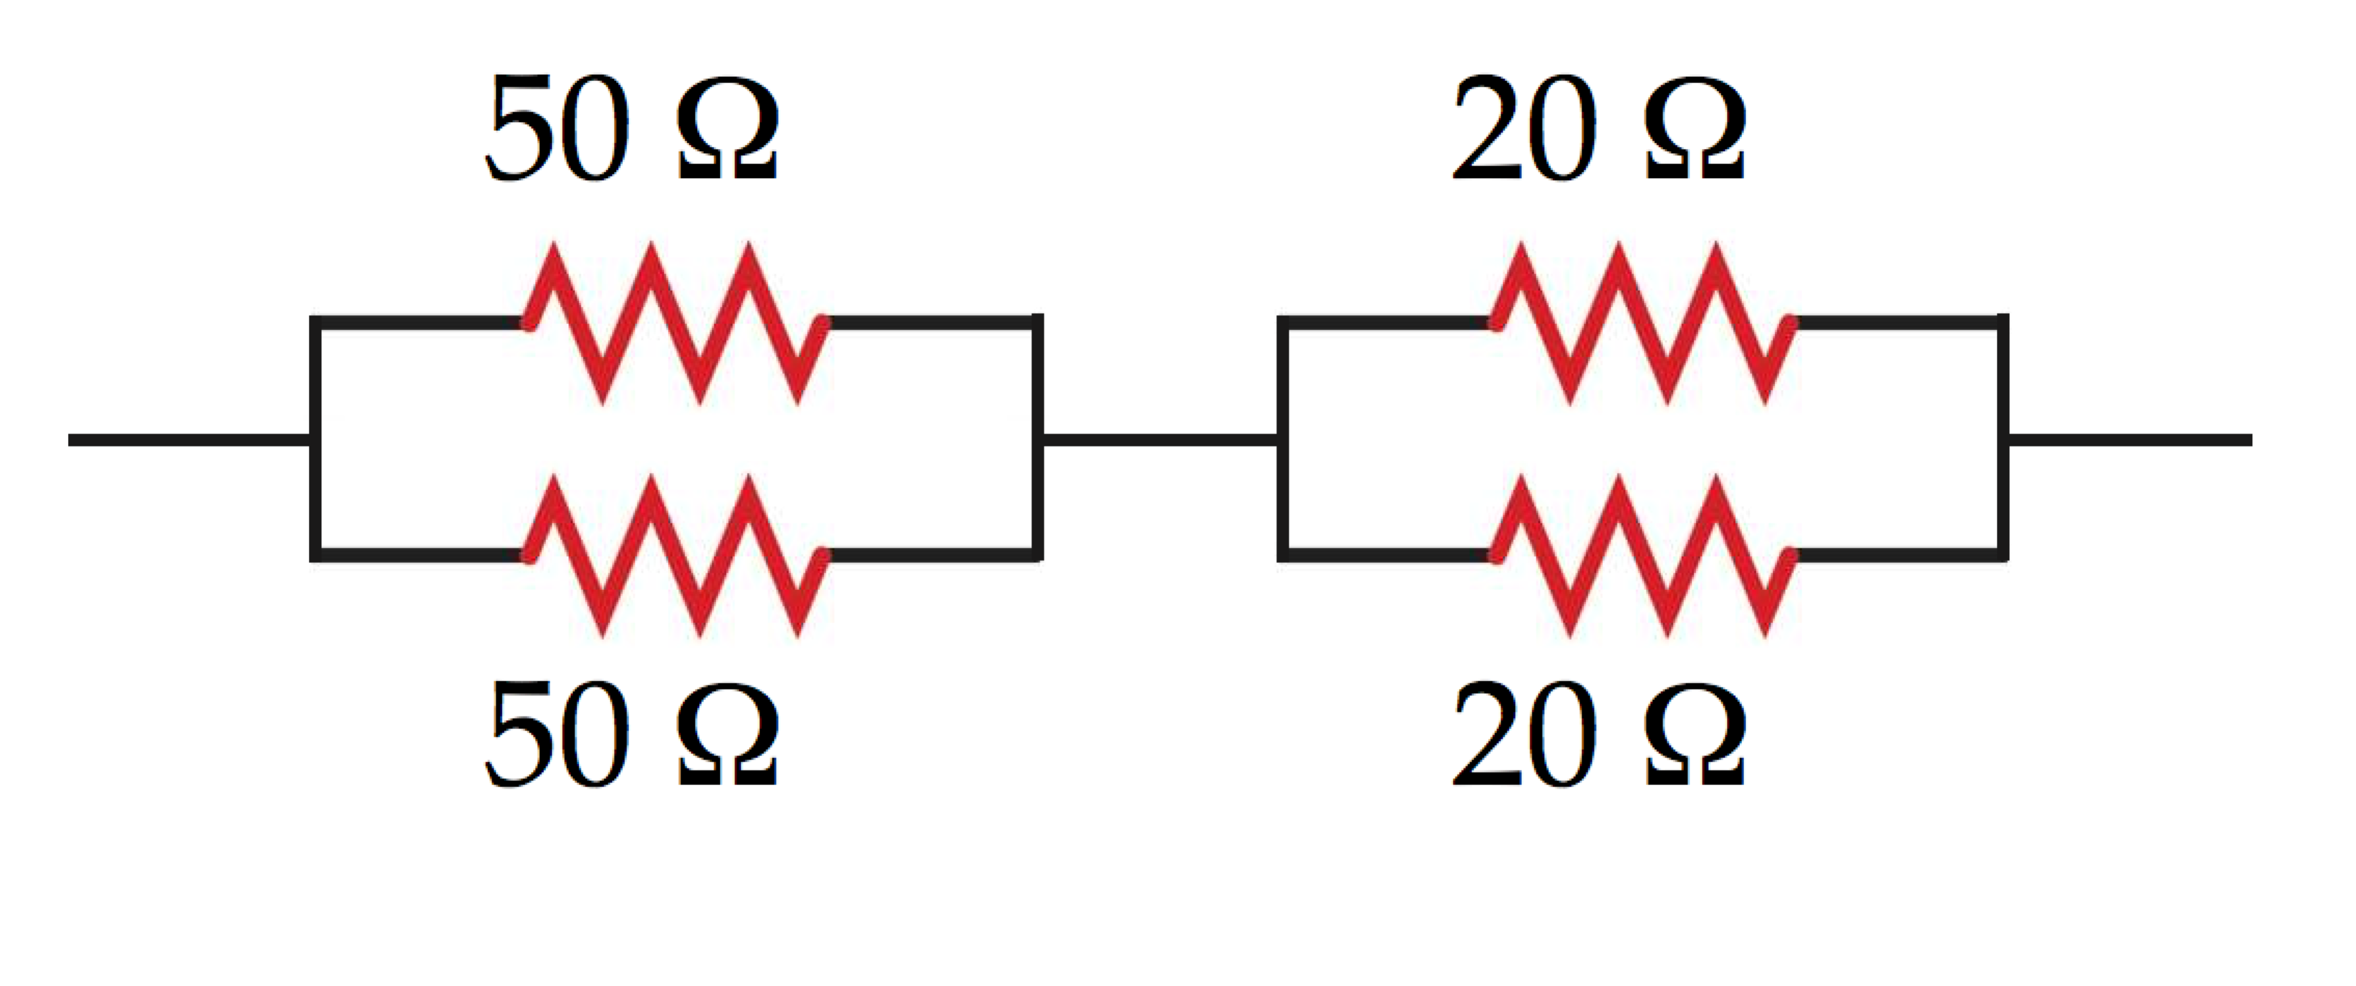

(b) The larger the total resistance, the more ways there are to add individual resistances and resistance combinations. Three examples are shown below:

105  = 5  + 100 

This can be formed with two of combination 2 in parallel and then combination 3 in series:

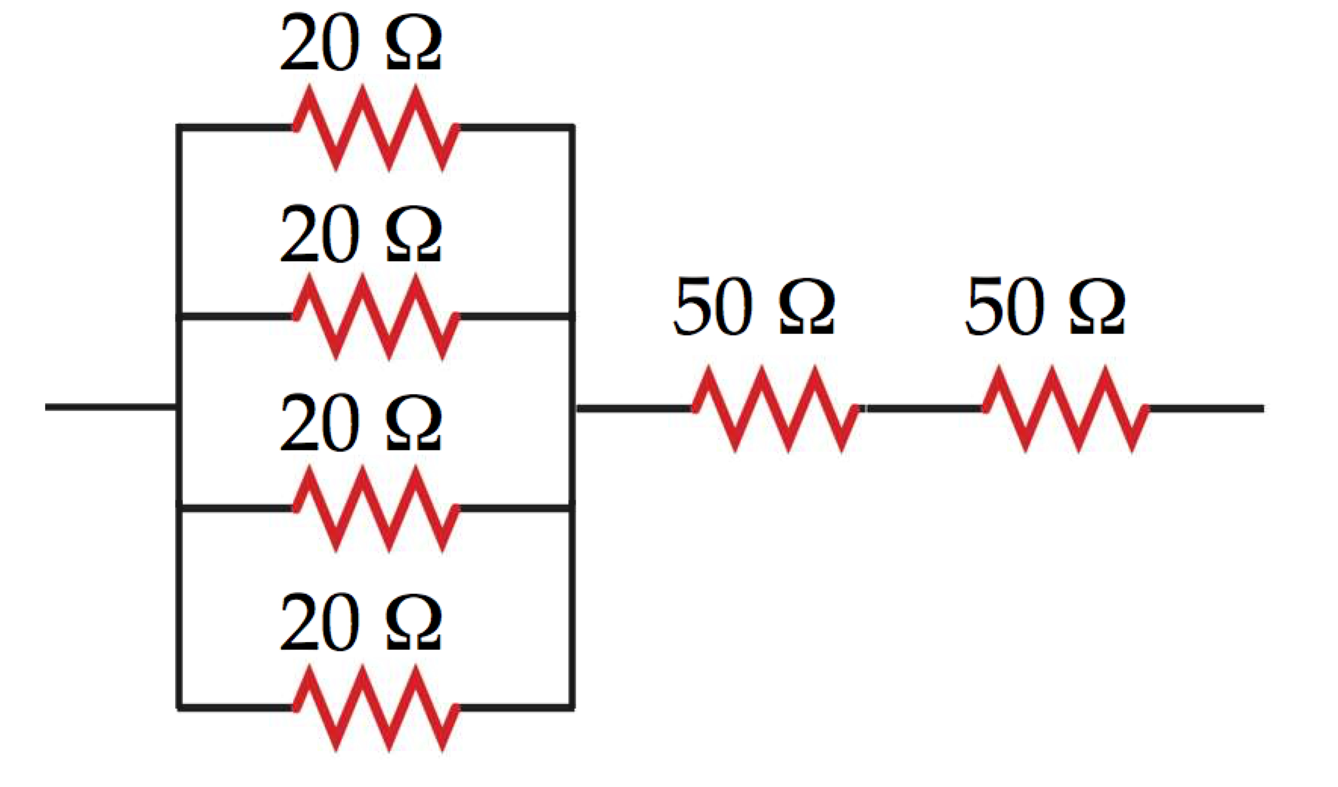

105  = 10  + 25  + 20  + 50 

This can be formed with a series connection of combination 4, combination 2, and one each of the available resistances:

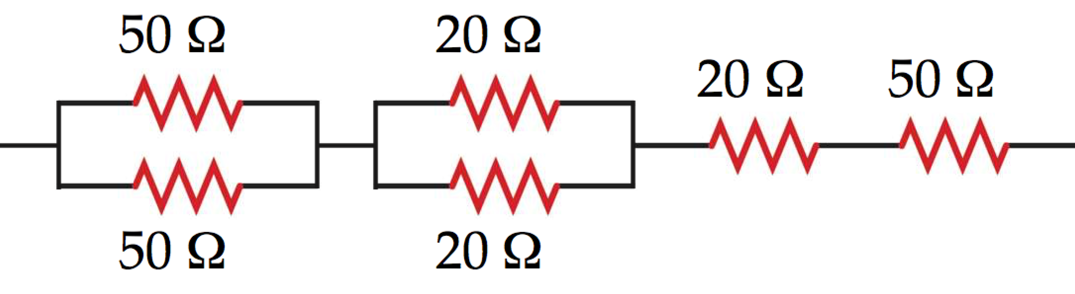

105  = 75  + 30  = 3(25 ) + 3(10  )

This can be formed with a series connection of four 20- resistors and combination 4:

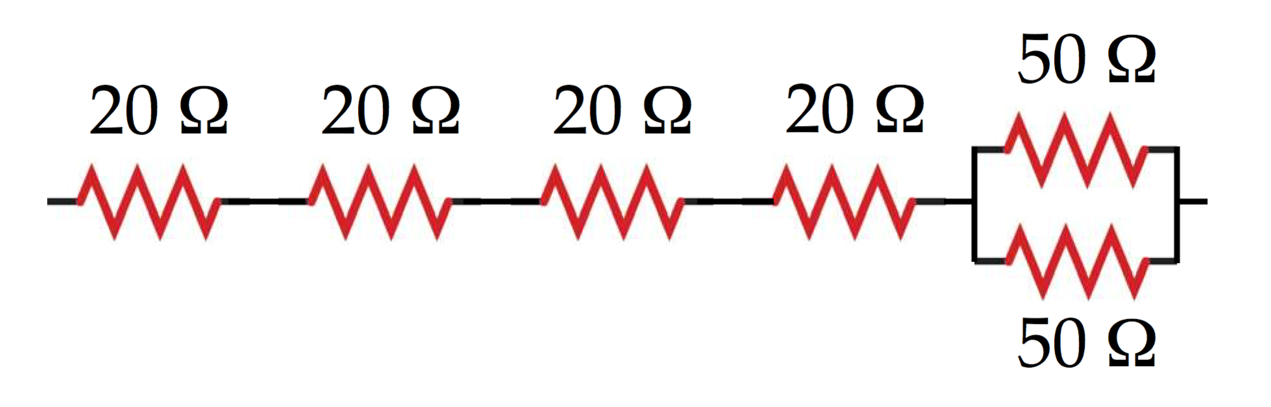  
**Finalize** Can all integer values of resistance be formed from these two available values? For example, beginning with the circuit in part (b), can you devise a combination of the available resistances to give a total resistance of 36 ? ]

*Answers:*

(a) (i) 

(ii) 

(b) Three possibilities:







**\*TP27.3** *Answers:* Answers will vary, depending on the choices made by students.

|  |
| --- |
| **SOLUTIONS TO END-OF-CHAPTER PROBLEMS** |

Section 27.1 Electromotive Force

P27.1 The total resistance is 

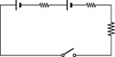

1.50 V

1.50 V





*R*

**ANS. FIG. P27.1**

(a) 

(b) 

**P27.2** (a) At maximum power transfer, *r* = *R*. Equal powers are delivered to *r* and *R*. The efficiency is 50.0%.

(b) For maximum fractional energy transfer to *R*, we want zero energy absorbed by *r*, so we want *r* = 0.

(c) High efficiency. The electric company’s economic interest is to minimize internal energy production in its power lines, so that it can sell a large fraction of the energy output of its generators to the customers.

(d) High power transfer. Energy by electric transmission is so cheap compared to the sound system that she does not spend extra money to buy an efficient amplifier.

**Section 28.2 Resistors in Series and Parallel**

**\*P27.3** C**onceptualize** You may not be familiar with these types of bulbs, but ask an older relative about them. Convince yourself from Figure P27.3 that the two filaments operate in parallel.

**Categorize** We model the light bulb using our knowledge of series and parallel resistors.

**Analyze** The light bulb circuit is redrawn below. Convince yourself that the circuit below is electrically identical to the one in Figure P27.3. The symbol at the left of the circuit represents an AC power source with a voltage of 120 V. We will study AC circuits in detail in Chapter 32.

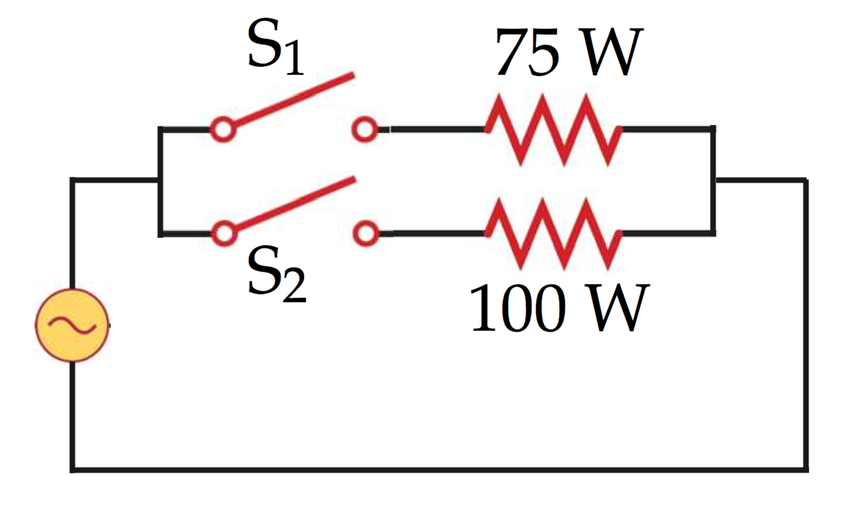

(a) With only switch S1 closed, only the 75-W filament is in the circuit, so the power to the bulb is 75 W.

(b) With only switch S2 closed, only the 100-W filament is in the circuit, so the power to the bulb is 100 W.

(c) With both switches S1 and S2 closed, power is supplied to both filaments, which are connected in parallel, so the power to the bulb is the sum, 175 W.

(d) If the 75-W filament breaks, the upper path in the circuit diagram above carries no current, and the operation of the bulb is independent of switch S1. There will only be light coming from the bulb when switch S2 is closed, corresponding to positions 3 and 4.

**Finalize** The ability to choose several light levels made these bulbs useful, but they required a specialized socket for the various switching possibilities.]

*Answers:* (a) 75 W (b) 100 W (c) 175 W (d) Two: switch positions 3 and 4. In both cases, the power is 100 W.

**P27.4**

(a) 

(b) See the circuit diagram in ANS7. FIG. P27.4; the 192-Ω resistor is the lightbulb (see below).

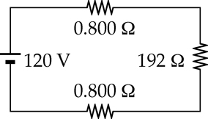

**ANS. FIG. P27.4**

(c) First, find the operating resistance of the lightbulb:



or 

From the circuit, the total resistance is 193.6 Ω. The current is



so the power delivered to the lightbulb is



**P27.5**

(a) By Ohm’s law, the current in *A* is  The equivalent resistance of the series combination of bulbs *B* and *C* is 2*R*. Thus, the current in each of these bulbs is 

(b) 

(c) 

**\*P27.6 Conceptualize** Recall any experiences you may have had with holiday strings of lights. If you used any series strings of lights before the new type of bulb was invented, you may recall the entire string going dark if one bulb were to fail. Categorize We model the entire string of lights as a combination of many resistors in series.

**Analyze** The power delivered to a single bulb is given by Equation 26.22:

 (1)

Because all the lightbulbs are identical in resistance and are connected in series, the applied voltage *V* is divided equally across all operating bulbs:

 (2)

where *n* is the number of bulbs still operating in the string. Substitute Equation (2) into Equation (1):

 (3)

Solve for *n*:

 (4)

Substitute numerical values:



This is the number of bulbs operating; the problem asked for the number of bulbs that have failed, which is



Therefore, if 15 bulbs fail, the dangerous power level is not reached, but it is exceeded if 16 bulbs fail. Therefore, the number of bulbs that can fail *before* the string of lights becomes dangerous is 15 bulbs.

**Finalize** If we graph Equation (3), we obtain a sense of the rising power as bulbs fail. The power in each bulb for the first 35 bulbs to fail is graphed below (we have left off bulbs 36–48 because the curve becomes very large, shrinking the curve for bulbs 0–35 to be indistinguishable from the horizontal axis.)

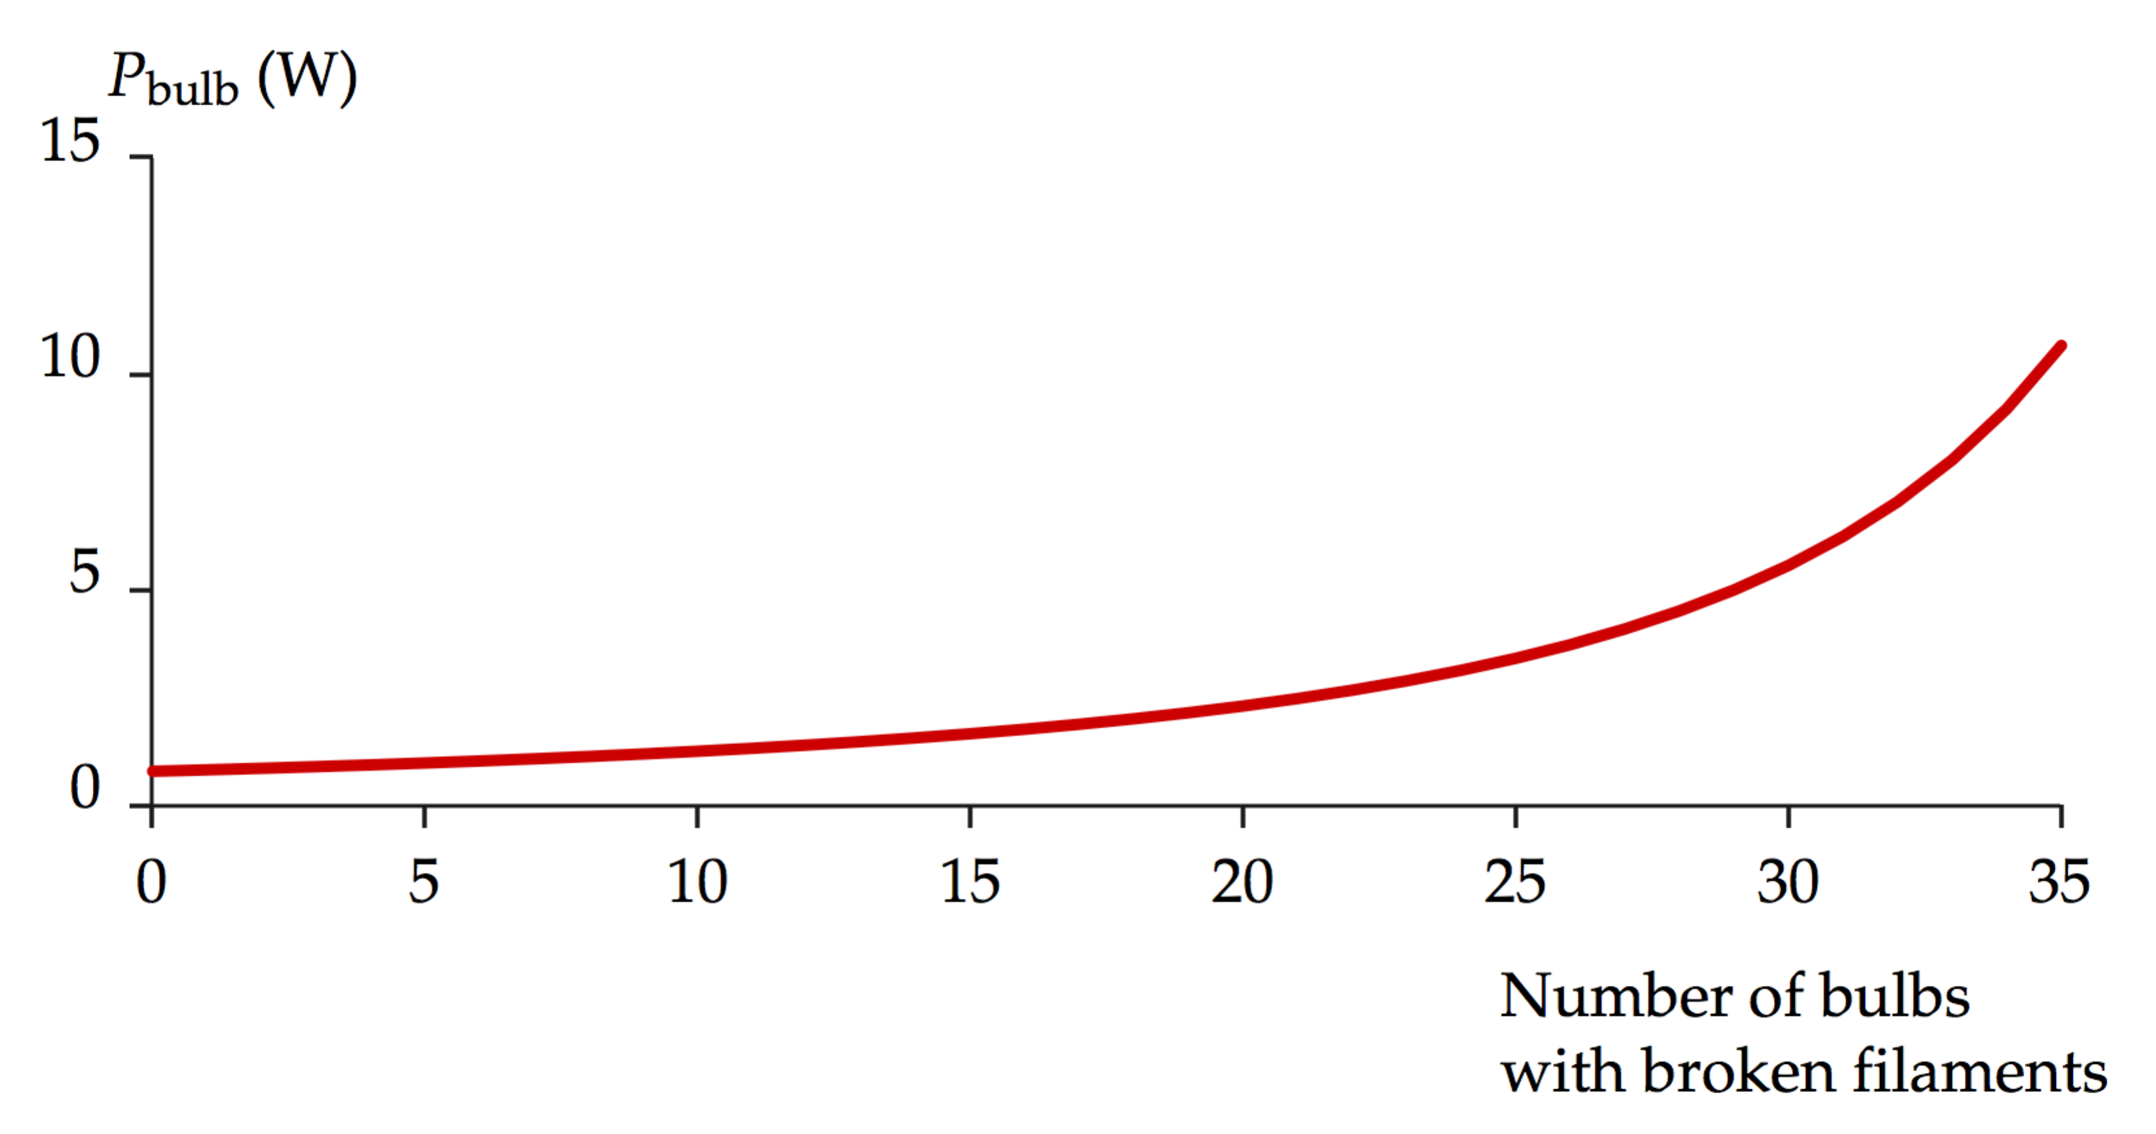

Notice that the power grows slowly for the first few bulbs to fail. As mentioned in the problem, if many bulbs fail, the remaining bulbs operate at a much higher temperature and represent a fire hazard. Furthermore, because of the higher filament temperature, the remaining bulbs may begin to fail sooner than normal, and the string of lights will climb the curve in the graph, with the number of bulb failures accelerating, until the last few bulbs fail dramatically in a short time interval.

*Answer:* 15 bulbs

**\*P27.7 Conceptualize** The resistance of the main resistor could be above or below the design value. Therefore, we may have to add resistors in either series, to increase the resistance, or parallel, to decrease it.

**Categorize** This is a problem that involves series and parallel combinations of resistors.

**Analyze** Resistances from 31.5  to 32.5  are in the acceptable range and do not need extra resistors. Therefore, keeping in mind the three-significant-figure measurement capability, the ranges over which we need correction are



Let us imagine first that the main resistance is too small. We will have to add an extra resistor in series to attain a larger equivalent resistance. Therefore the largest resistance to be added in series will be associated with achieving the desired equivalent resistance, 32.0 , for the lowest observed main resistance between the limits of 30.4  and 31.4 .

Therefore,

 (1)

Substitute numerical values to find the largest extra resistance needed in series for the limits of the range:





So the series combination gives us a requirement of



Now imagine that the main resistance is too large. We need to reduce the equivalent resistance by adding an extra resistor in parallel. Therefore, the extra resistance to be added in parallel will be associated with achieving the desired equivalent resistance, 32.0 , for a main resistance between the limits of 32.6  and 33.6 . (The higher the main resistor is above the desired value, the *smaller* must be the extra resistance to be added in parallel.) Therefore, for a parallel combination,

 (1)

Substitute numerical values to find the largest extra resistance needed for the limits of the range:





Therefore, the range of extra resistances required is



**Finalize** How would the answers change if your team decided that the corrected resistances did not have to be exactly 32.0 ? For example, what if the corrected resistance were allowed to be in the range of 31.8  to 32.2 ?

*Answer:*  and 

**\*P27.8 Conceptualize** Let’s imagine a carbon wire of length *L*C placed end to end with a Nichrome wire of the same radius *r* and length *L*N. We want the resistance of the series combination of wires to be *R*. That’s easy. More complicated is the requirement that the resistance not vary with temperature.

**Categorize** This problem combines our understanding of series combinations of resistors with our understanding of the temperature variation of resistance.

**Analyze** Let’s first apply the requirement that the total resistance of the series combination be *R*. Using Equation 27.8, we have

 (1)

Now, let’s impose the requirement that the temperature variation of resistance be zero. Looking at Table 26.2, we see Nichrome has a positive temperature coefficient and carbon has a negative coefficient. We must have opposite signs for the temperature coefficient in order for the decrease in resistance of one material to compensate for the increase in the other. If these changes are to exactly cancel each other out, then we must have, from Equation 26.20, for any temperature change ∆*T*,

 (2)

Substitute into Equation (1):

 (3)

Substitute for *R*N from Equation 26.10:

 (4)

Solve Equation (4) for the length *L*N:

 (5)

Substitute numerical values:



We could follow the same procedure to generate a parallel expression to Equation (5) for the length of the carbon:

 (6)

Substitute numerical values:



**Finalize** Notice that the length of each segment is proportional to the square of the radius *r*. Therefore, one could adjust the radius and find new lengths if the overall length of the combination is too long or too short. Notice also that we have ignored the different coefficients of thermal expansion of the two materials, so the assumption that the two components of the wire always have the same radius will not be true. This, however, is a very small effect.

*Answers:* Nichrome: 0.393 m; carbon: 8.98 × 10–3 m

**P27.9** When *S* is open, R1, R2, and R3 are in series with the battery. Thus,

 **[1]**

When *S* is closed in position *a*, the parallel combination of the two R2’s is in series with R1, R3, and the battery. Thus,

 **[2]**

When *S* is closed in position *b*, R1 and R2 are in series with the battery and R3 is shorted. Thus,

 **[3]**

Subtracting [3] from [1] gives R3 = 3 kΩ.

Subtracting [2] from [1] gives R2 = 2 kΩ.

Then, from [3], R1 = 1 kΩ.

Answers: (a)  (b)  (c) 

**P27.10** When *S* is open, R1, R2, and R3 are in series with the battery. Thus,

 **[1]**

WhenS is closed in position *a*, the parallel combination of the two R2’s is in series with R1, R3, and the battery. Thus,

 **[2]**

When *S* is closed in position *b*, R1 and R2 are in series with the battery. R3 is shorted. Thus:

 **[3]**

Subtracting [3] from [1] gives



Subtracting [2] from [1] gives



Then, from [3],



Answers: (a)  (b) 

(c) 

**\*P27.11 Conceptualize** Model the hot dogs as resistors, and apply the laws of combining resistances in series and parallel!

**Categorize** As noted in the Conceptualize step, we categorize this problem as an application of the laws for combining resistances in series and parallel.

**Analyze** (a) First recognize that the 120 V is connected directly across the single hot dog and the two hot dogs in parallel. So all of these hot dogs receive the same amount of power and will cook at the same time. The two hot dogs in series will represent a larger resistance than that for a single hot dog. This will reduce the current through the combination of hot dogs in series, and therefore, the power delivered. Therefore, the single hot dog and the two in parallel will all cook first.

(b) Now, let’s evaluate the time interval. We begin with Equation 26.22:

 (1)

Substitute the definition of power and solve for the time interval:

 (2)

where *T*ET is the energy that must be transferred to the hot dog by electrical transmission to cook it. Substitute numerical values:



This is the time interval for the single hot dog and the two in parallel. For the two hot dogs in series, each hot dog receives half of the applied voltage of 120 V. Therefore, from Equation (2), for the hot dogs in series,



**Finalize** Do not try this demonstration at home! It is inherently dangerous, especially if you touch the hot dogs while the current exists in them. The cookers that worked by this principle would not activate unless the hot dog was enclosed completely so that there was no way the operator could touch its surface.]

*Answers:* (a) The single hot dog and the two in parallel will all cook first. (b) single hot dog and the two in parallel: 57.3 s; two hot dogs in series: 229 s

**P27.12** The resistance of the combination of extra resistors must be  The possible combinations are: one resistor: *R*; two resistors: 2*R*,  three resistors: 3*R*,  None of these is  so the desired resistance cannot be achieved.

**P27.13** To find the current in each resistor, we find the resistance seen by the battery. The given circuit reduces as shown in ANS. FIG. P27.13 (a), since



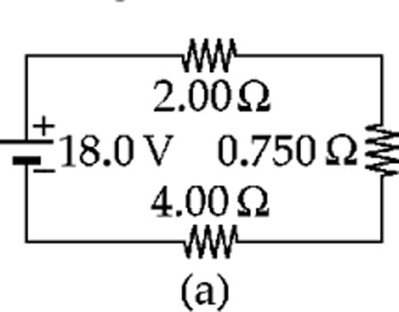

In ANS. FIG. P27.13 (b),

*I* = 18.0 V/6.75 Ω = 2.67 A

This is also the current in ANS. FIG. P27.13 (a), so  
 the 2.00-Ω and 4.00-Ω resistors convert powers

**ANS. FIG. P27.13**

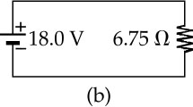

**

and **

The voltage across the 0.750-Ω resistor in   
ANS. FIG. P27.13 (a), and across both the 3.00-Ω   
and the 1.00-Ω resistors in Figure P27.13, is

**

Then for the 3.00-Ω resistor,



and the power is



For the 1.00-Ω resistor,



**P27.14** We assume that the metal wand makes low-resistance contact with the

person’s hand and that the resistance through the person’s body is negligible

compared to the resistance Rshoes of the shoe soles. The equivalent resistance seen

by the power supply is 1.00 MΩ + Rshoes. The current through both resistors is  The voltmeter displays



(a) We solve to obtain





or



where resistance is measured in MΩ.

(b) With , the current through the person’s body is

 

**P27.15** (a) The resistors 2, 3, and 4 can be combined to a single 2*R* resistor. This is in series with resistor 1, with resistance *R*, so the equivalent resistance of the whole circuit is 3*R*. In series, potential difference is shared in proportion to the resistance, so resistor 1 gets  of the battery voltage and the 2-3-4 parallel combination gets  of the battery voltage. This is the potential difference across resistor 4, but resistors 2 and 3 must share this voltage.  goes to 2 and  to 3. The ranking by potential difference is



Based on the reasoning above the potential differences are



(b) All the current goes through resistor 1, so it gets the most. The current then splits at the parallel combination. Resistor 4 gets more than half, because the resistance in that branch is less than in the other branch. Resistors 2 and 3 have equal currents because they are in series. The ranking by current is



Resistor 1 has a current of *I*. Because the resistance of 2 and 3 in series is twice that of resistor 4, twice as much current goes through 4 as through 2 and 3. The current through the resistors are



(c) Increasing resistor 3 increases the equivalent resistance of the entire circuit. The current in the circuit, which is the current through resistor 1, decreases. This decreases the potential difference across resistor 1, increasing the potential difference across the parallel combination. With a larger potential difference the current through resistor 4 is increased. With more current through 4, and less in the circuit to start with, the current through resistors 2 and 3 must decrease. To summarize,



(d) If resistor 3 has an infinite resistance it blocks any current from passing through that branch, and the circuit effectively is just resistor 1 and resistor 4 in series with the battery. The circuit now has an equivalent resistance of 4*R*. The current in the circuit drops to  of the original current because the resistance has increased by . All this current passes through resistors 1 and 4, and none passes through 2 or 3. Therefore,



**\*P27.16 Conceptualize** Hmmm. Good question! It might appear possible that the live battery would create a clockwise current from its terminals, causing the current in the dead battery to be downward, thereby charging it. But we can’t be sure unless we analyze the circuit carefully.

**Categorize** This is a multiloop circuit for which we must use Kirchhoff’s rules.

**Analyze** Let us first draw current arrows on the resistors in the situation after the switch is closed:

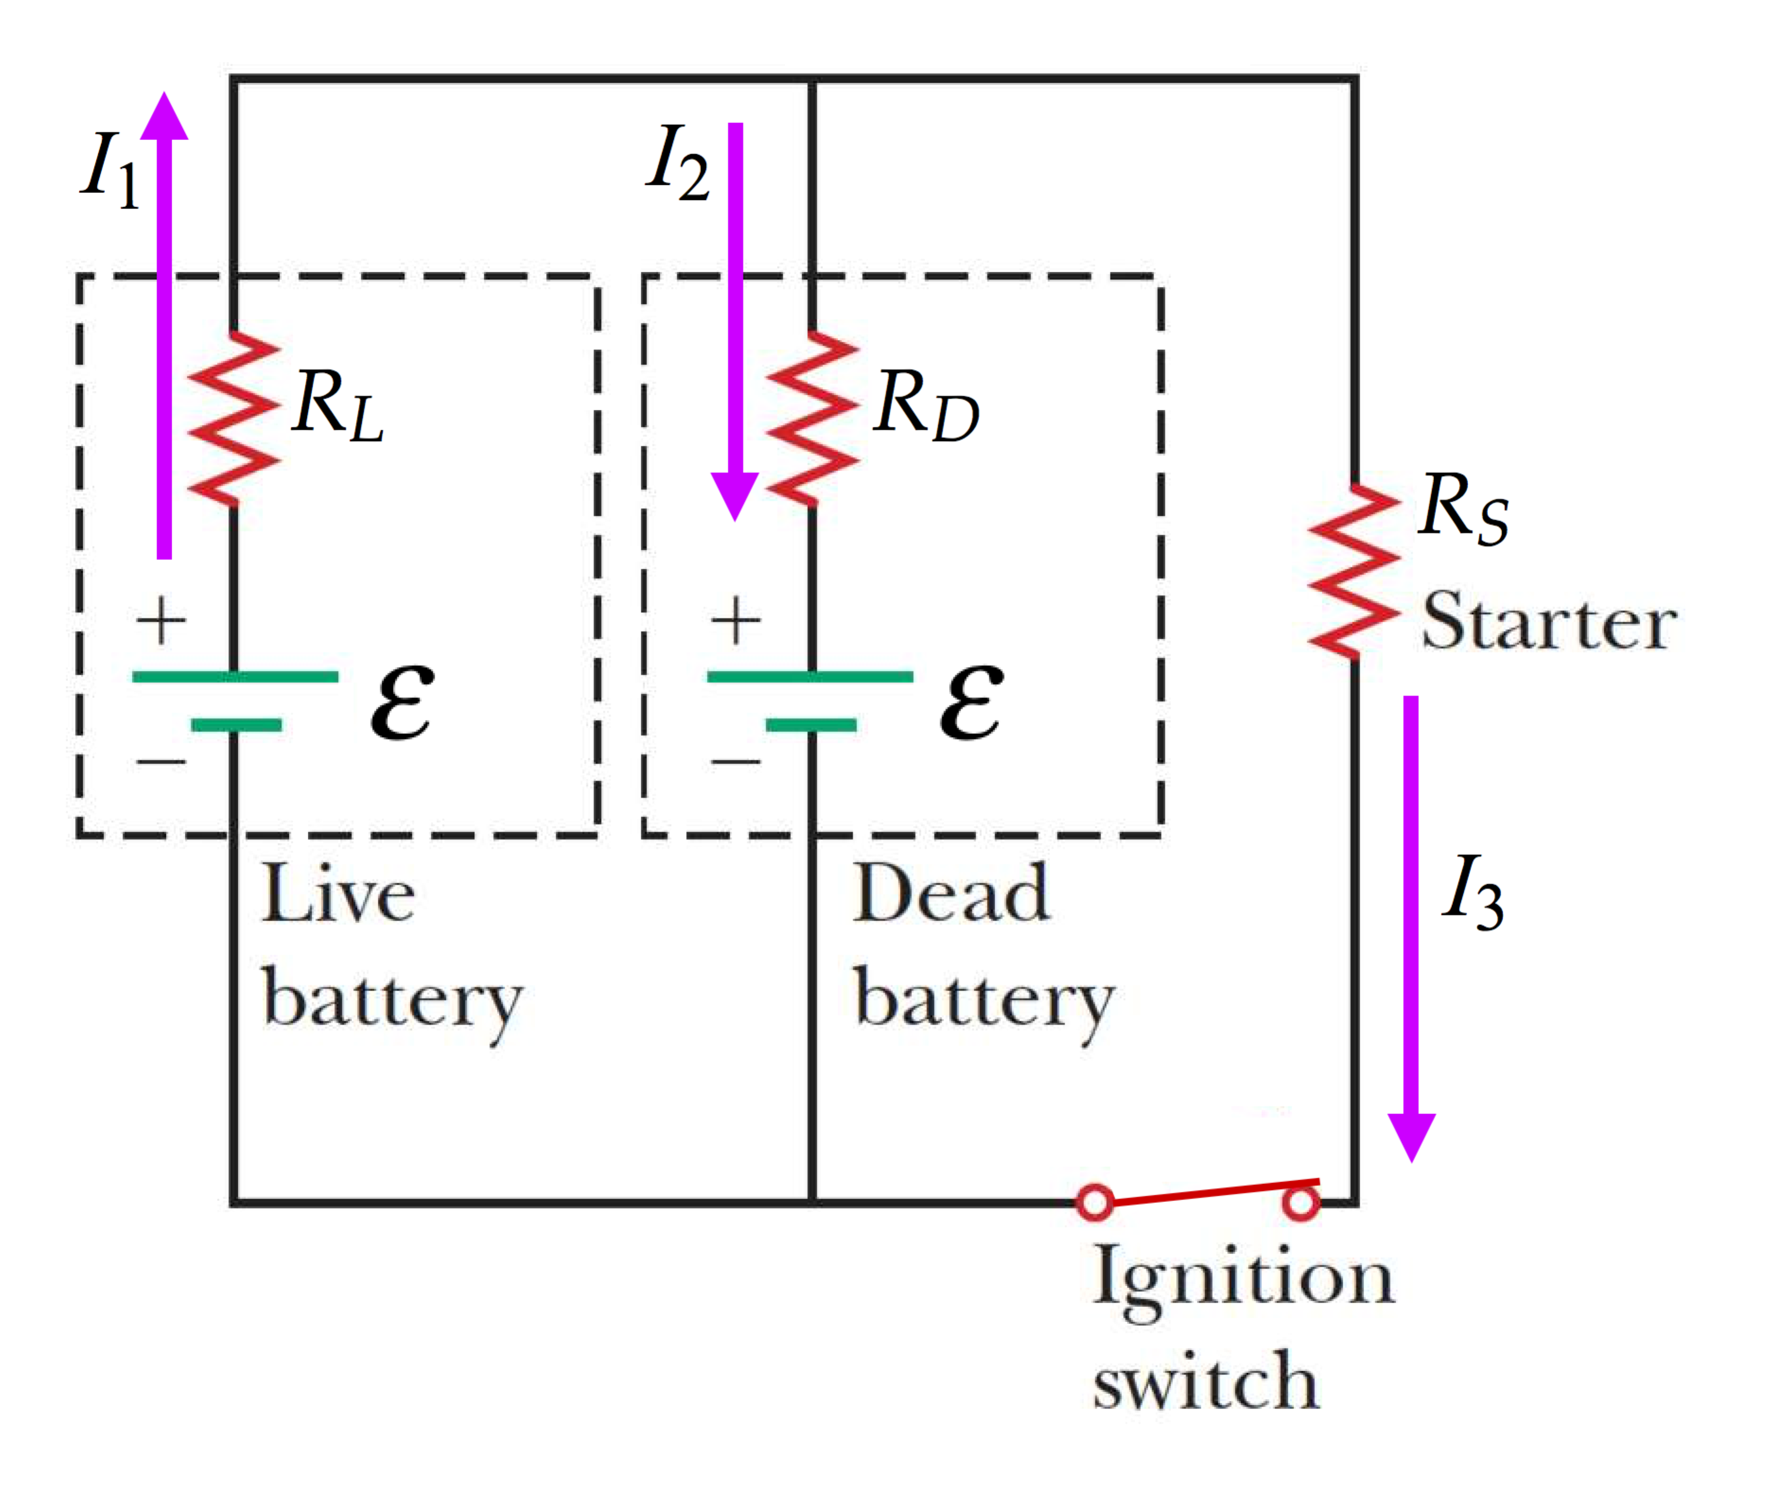

Write Kirchhoff’s junction rule at the junction at the middle of the top of the circuit:

 (1)

Now write Kirchhoff’s loop rule for the outer loop, traveling in the clockwise direction:

 (2)

Finally, write Kirchhoff’s loop rule for the left-hand loop, traveling in the clockwise direction:

 (3)

From Equation (3),

 (4)

From Equation (2),

 (5)

Substitute Equation (5) into Equation (1):

 (6)

Substitute Equation (6) into Equation (4) and solve for *I*2:

 (7)

All variables on the right of Equation (7) are positive, so the current *I*2 is negative. Because *I*2 is negative, the current is in the opposite direction to that chosen in the figure. Therefore, the current in the dead battery is upward in the diagram, and the dead battery is NOT being charged while the starter operates.

**Finalize** Even though it would not start the car on its own, the dead battery does contribute a small amount to the starter circuit. Notice that Equation (7) gives a negative current *regardless of the value of the internal resistance of the dead battery*!]

*Answer:* No, the battery is not being charged.

Section 28.3 Kirchhoff’s Rules

**P27.17** We name currents I1, I2, and I3 as shown in ANS. FIG. P27.17.

**ANS. FIG. P27.17**

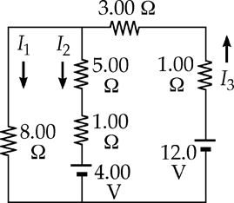

From Kirchhoff’s current rule, I3 = I1 + I2.

Applying Kirchhoff’s voltage rule to the

loop containing I2 and I3,



Applying Kirchhoff’s voltage rule to the loop containing I1 and I2,



or 

Solving the above linear system (by substituting *I*1 + *I*2 for *I*3), we proceed to the pair of simultaneous equations:

 or 

and to the single equation



which gives



Then 

and 

give 

(a) The results are: 0.846 A down in the 8.00-Ω resistor; 0.462 A down in the middle branch; 1.31 A up in the right-hand branch.

(b) For 4.00-V battery:



For 12.0-V battery:



The results are: –222 J by the 4.00-V battery and 1.88 kJ by the 12.0-V battery.

(c) To the 8.00-Ω resistor:



To the 5.00-Ω resistor:



To the 1.00-Ω resistor in the center branch:



To the 3.00-Ω resistor:



To the 1.00-Ω resistor in the right-hand branch:



(d) 

(e) Either sum the results in part (b): –222 J + 1.88 kJ = 1.66 kJ,

or in part (c): 687 J + 128 J + 25.6 J + 616 J +205 J = 1.66 kJ

The total amount of energy transformed is 1.66 kJ

**P27.18** (a) The first equation represents Kirchhoff’s loop theorem. We choose to think of it as describing a clockwise trip around the left-hand loop in a circuit; see ANS. FIG. P27.18(a).

For the right-hand loop see ANS. FIG. P28.18(b). The junctions must be between the 5.80-V emf and the 370-Ω resistor and between the 370-Ω resistor and the 150-Ω resistor. Then we have ANS. FIG. P28.18(c). This is consistent with the third equation,

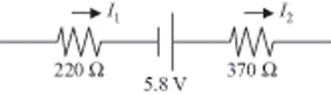

**ANS. FIG. P27.18(a)**



(b) Suppressing units, we substitute:

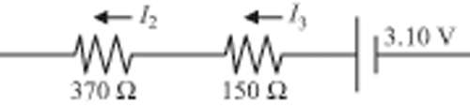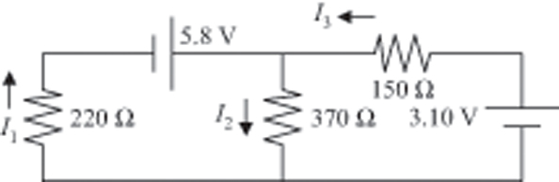

**ANS. FIG. P27.18(b)**

**ANS. FIG. P27.18(c)**



Next , 



**P27.19** Label the currents in the branches as shown in ANS. FIG. P27.19(a). Reduce the circuit by combining the two parallel resistors as shown in ANS. FIG. P27.19(b).

Apply Kirchhoff’s loop rule to both loops in ANS. FIG. P27.19(b) to obtain:



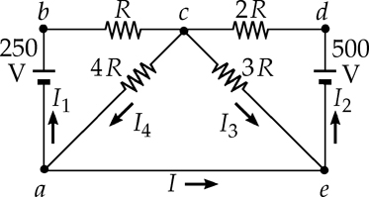

**ANS. FIG. P27.19(a)**

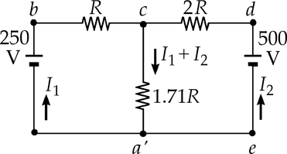

**ANS. FIG. P27.19(b)**



With *R* = 1 000 Ω, simultaneous solution of these equations yields:

*I*1 = 10.0 mA

*I*2 = 130.0 mA

From ANS. FIG. P27.19(b), 

Thus, from ANS. FIG. P27.19(a), 

Finally, applying Kirchhoff’s point rule at point *a* in ANS. FIG. P27.19(a) gives:



or 

**P27.20** Following the path of *I*1 from *a* to *b*, and recording changes in potential gives



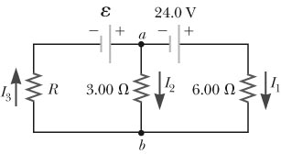

**ANS. FIG. P27.20**

Now, following the path of *I*2 from *a* to *b*, and recording changes in potential gives



which means the initial choice of the direction of *I*2 in Figure P27.20 was incorrect. Applying Kirchhoff’s junction rule at point *a* gives



The results are:

(a) 

(b)  and flows in the direction shown in Figure P27.20.

(c) 

**P27.21** (a)  Some simplification could be made by recognizing that the 2.0 Ω and 4.0 Ω resistors are in series, adding to give a total of 6.0 Ω; and the 5.0 Ω and 1.0 Ω resistors form a series combination with a total resistance of 6.0 Ω.  


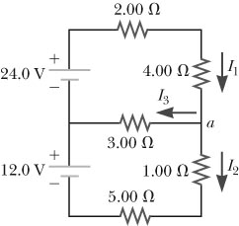

**ANS. FIG. P27.21**

(b) Applying Kirchhoff’s junction rule at junction *a* gives

*I*1 = *I*2 + *I*3 **[1]**

Using Kirchhoff’s loop rule on the upper loop yields



or  **[2]**

and for the lower loop,



Using equation [2], this reduces to



giving

 **[3]**

Substituting equations [2] and [3] into [1] gives 

(c) Then, equation [3] gives , and

(d) Equation [2] yields 

**P27.22** (a) Going counterclockwise around the upper loop and suppressing units, Kirchhoff’s loop rule gives



or  **[1]**

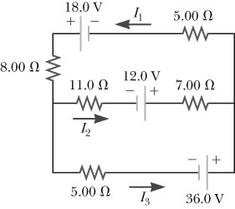

**ANS. FIG. P27.22**

(b) Going counterclockwise around the lower loop:



or  **[2]**

(c) Applying the junction rule at the node in the left end of the circuit gives  **[3]**

(d) Solving equation [3] for *I*3 yields  **[4]**

(e) Substituting equation [4] into [2] gives



or  **[5]**

(f) Solving equation [5] for *I*1 yields . Substituting this into equation [1] gives







Then, from equation [2],  which yields



(g) Equation [4] gives



(h) 

Section 27.4 RC Circuits

P27.23 (a) The time constant of the circuit is



(b) The maximum charge on the capacitor is given by Equation 28.13:



(c) We use , when *t = RC*. Then,



**\*P27.**24 Conceptualize The discussion of Section 27.4 shows that the time constant should have imensions of time. In this problem, we verify the dimensions. Categorize The problem is categorized as a substitution problem. Follow the technique for determining the dimensions of a quantity introduced in Section 1.3:

]

**P27.25** (a) Before the switch is closed, the two resistors are in series. The time constant is



(b) After the switch is closed, the capacitor discharges through resistor *R*2. The time constant is



(c) Before the switch is closed, there is no current in the circuit because the capacitor is fully charged, and the voltage across the capacitor is  After the switch is closed, current flows clockwise from the battery to resistor *R*1 and down through the switch, and current from the capacitor flows counterclockwise and down through the switch to resistor *R*2; the result is that the total current through the switch is *I*1 + *I*2.

Going clockwise around the left loop,



so the battery carries current 

Going counterclockwise around the right loop,



so the 100-kΩ resistor carries current of magnitude



and the switch carries downward current



**P27.26** a) Before the switch is closed, the two resistors are in series. The time constant is



(b) After the switch is closed, the capacitor discharges through resistor *R*2. The time constant is



(c) Before the switch is closed, there is no current in the circuit because the capacitor is fully charged, and the voltage across the capacitor is  After the switch is closed, current flows clockwise from the battery to resistor *R*1 and down through the switch, and current from the capacitor flows counter clockwise and down through the switch to resistor *R*2; the result is that the total current through the switch is *I*1 + *I*2. Going clockwise around the left loop,

 is the current in the battery.

Going counter clockwise around the right loop,



is the magnitude of the current in *R*2. The total current through the switch is



**P27.27** The potential difference across the capacitor is



Using 1 farad = 1 s/Ω,



Therefore,



or 

Taking the natural logarithm of both sides,



and 

**P27.28** We are to calculate



Section 28.5 Household Wiring and Electrical Safety

**\*P27.29 Conceptualize** You may be familiar with the necessity of avoiding having too many things plugged into the same outlet, since they all draw power. This is especially true of devices that raise the temperature of something, such as waffle irons, toasters, coffeemakers, curling irons, blow dryers, etc. Circuit breakers limit the current in a given household circuit, to avoid overheating the wires and causing a fire.

**Categorize** This is a relatively simple substitution problem. We need to find the total current in a circuit if you know the power delivered from the source.

Find the current from Equation 26.21:



Substitute the total power for all the devices in the numerator and the household voltage of 120 V in the denominator:



This is larger than the tripping voltage for the circuit breaker, so the breaker will trip.

*Answer:* No

**P27.30**  (a)  So for the heater, 

For the toaster, 

And for the grill, 

(b) The total current drawn is 12.5 A + 6.25 A + 8.33 A = 27.1 A.



**P27.31** (a) Suppose that the insulation between either of your fingers and the conductor adjacent is a chunk of rubber with contact area 4 mm2 and thickness 1 mm. Its resistance is



The current will be driven by 120 V through total resistance (series)



It is: 

(b) The resistors form a voltage divider, with the center of your hand at potential , where *V*h is the potential of the “hot” wire. The potential difference between your finger and thumb is



So the points where the rubber meets your fingers are at potentials of

 and 

**Additional Problems**

**P27.32** The battery current is



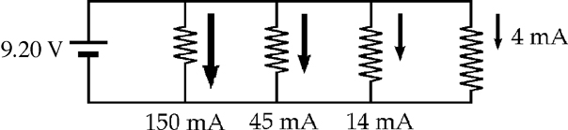

ANS. FIG. P27.32

(a) The resistor with highest resistance is that carrying 4.00 mA. Doubling its resistance will reduce the current it carries to   
2.00 mA. Then the total current is (150 + 45 + 14 + 2) mA =   
211 mA, nearly the same as before. The ratio is 

(b) The resistor with least resistance carries 150 mA. Doubling its resistance changes this current to 75 mA and changes the total to

(75 + 45 + 14 + 4) mA = 138 mA. The ratio is 

(c) 

**P27.33** The resistive network between *a* an *b* reduces, in the stages shown in ANS. FIG. P27.33, to an equivalent resistance of .

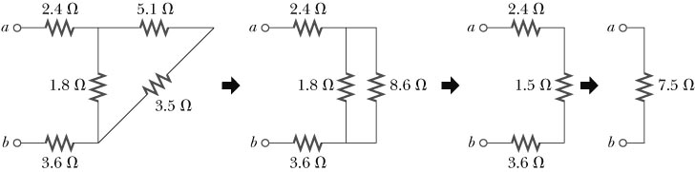

ANS. FIG. P27.33

**P27.34** The current in the battery is 

The voltage across 5 Ω is 15 V – (10 Ω) (1.15 A) = 3.53 V.

(a) The current in it is 3.53 V/5 Ω = 0.706 A.

(b) *P* = (3.53 V) (0.706 A) = 2.49 W.

(c) 

(d) 

**P27.35** Several seconds is many time constants, so the capacitor is fully charged and (d) the current in its branch is zero.

For the center loop, Kirchhoff’s loop rule gives

+8 + (3 Ω) *I*2 – (5 Ω)*I*1 = 0

or *I*1 = 1.6 + 0.6*I*2 **[1]**

For the right-hand loop, Kirchhoff’s loop rule gives

+4 V – (3 Ω) *I*2 – (5 Ω) *I*3 = 0

or *I*3 = 0.8 – 0.6*I*2 **[2]**

For the top junction, Kirchhoff’s junction rule gives

+ *I*1 + *I*2 – *I*3 = 0 **[3]**

Now we eliminate *I*1 and *I*3 by substituting [1] and [2] into [3]. Suppressing units,

1.6 + 0.6*I*2 + *I*2 – 0.8 + 0.6*I*2 = 0 → *I*2 = –0.8/2.2 = –0.3636

(b) 

(a) Now, from [2], we find *I*3 = 0.8 – 0.6(*–* 0.364) = 1.02 A down in 4 V and in 5 Ω.

(c) From [1] we have *I*1 = 1.6 + 0.6(*–* 0.364) = 1.38 A up in the 8 V battery.

(e) For the left loop +3 V – (*Q*/6 *µ*F) + 8 V = 0, so *Q* = (6 *µ*F) (11 V) = 66.0 *µ*C

**P27.36** The equivalent resistance is Req = *R* + Rp, where Rp is the total resistance of the three parallel branches;



Thus,



which reduces to



or 

Only the positive solution is physically acceptable, so .

**P27.37** (a) Using Kirchhoff’s loop rule for the closed loop,

+12.0 – 2.00*I* – 4.00*I* = 0

so *I* = 2.00 A

Then,



Thus, 

(b) ; thus, .

**P27.38** Find an expression for the power delivered to the load resistance *R*:



where 

Carry out the squaring process:





where .

Solve the quadratic equation:



Evaluate *b*:



Substitute numerical values into the expression for *R*:



There is no real solution to this expression for *R*. Therefore, no load resistor can extract 21.2 W from this battery.

**P27.39** Let the two resistances be *x* and *y.*

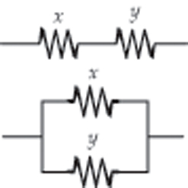

**ANS. FIG. P27.39**

Then,



and 

so 



Factoring the second equation,



so *x* = 6.00 Ω or *x* = 3.00 Ω

Then, *y* = 9.00 Ω – *x* gives

*y* = 3.00 Ω or *y* = 6.00 Ω

There is only one physical answer: The two resistances are  and .

**P27.40** Refer to ANS. FIG. P27.39 above. Let the two resistances be *x* and *y.*

Then,  and .

From the first equation,  and the second

becomes  or .

Using the quadratic formula, .

Then,  gives .

The two resistances are  and .

**P27.41** The total resistance in the circuit is



and the total capacitance is



Thus, 

and 

The total stored charge at any time *t* is then



or  **[1]**

Since the capacitors are in parallel with each other, the same potential difference exists across both at any time.

Therefore,

 **[2]**

(a) Substituting equation [2] into [1] gives



or , where *q* is in microcoulombs and *t* is in milliseconds.

(b) and from equation [2],



or, , where *q* is in microcoulombs and *t* is in milliseconds

**P27.42**  (a) In the diagram we could show the two resistors connected top end to top end and bottom end to bottom end with wires; we represent this connection instead by showing the bottom ends of both resistors connected to ground. The ground represents a conductor that is always at zero volts, and also can carry any current. Think of *I*, *R*1, and *R*2 as known quantities. We represent the current in *R*1 as the unknown *I*1. Then the current in the second resistor must by *I* – *I*1. The total potential difference clockwise around the little loop containing both resistors must be zero:

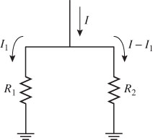

**ANS. FIG. P27.42**

–(*I* – *I*1)*R*2 + *I*1*R*1 + 0

We can already solve for *I*1 in terms of the total current:



Then the current in the second resistor is

*I*2 = *I* – *I*1 = *I* – *IR*2 /(*R*1 + *R*2) = *I*(*R*1 + *R*2 – *R*2)/(*R*1 + *R*2)

**

(b) Continue to think of *I*, *R*1, and *R*2 as known quantities and *I*1 as an unknown. The power being converted by both resistors together is *P* = *I*12*R*1 + (*I* – *I*1)2*R*2. Because the current is squared, the power would be extra large if all of the current went through either one of the resistors with zero current in the other. The minimum power condition must be with a more equitable division of current, and we find it by taking the derivative of *P* with respect to *I*1 and setting the derivative equal to zero:

*dP*/*dI*1 = 2 *I*1*R*1 + 2(*I* – *I*1)(0 – 1)*R*2 = 0

Again we can solve directly for the real value of *I*1 in

*I*1*R*1 – *IR*2 + *I*1*R2* = 0 as *I*1 = *IR*2/(*R*1 + *R*2)

So then again

*I*2 = *I* – *I*1 = *IR*1/(*R*1 + *R*2)

This power-minimizing division of current is the same as the voltage-equalizing division of current that we found in part (a), so the proof is complete.

**P27.43** (a) Around the circuit,



Substituting numerical values,



so 

(b) Inside the supply,



(c) Inside both batteries together, 

(d) For the limiting resistor,



(e) 

**P27.44** The battery supplies energy at a changing rate



Then the total energy put out by the battery is 



The power delivered to the resistor is



So the total internal energy appearing in the resistor is 



The energy finally stored in the capacitor is  Thus, energy of the circuit is conserved,  and resistor and capacitor share equally in the energy from the battery.

**P27.45** (a) The emf of the battery is 

(b) Its internal resistance is given by



(c) The batteries are in series: Total emf = 2(9.30 V) = 18.6 V.

(d) The batteries are in series, so their total internal resistance is   
2*r* = 5.03 Ω. The maximum current is given by

**

(e) For the circuit the total series resistance is

*R*eq = 2*r* + 12.0 Ω = 17.0 Ω

and

**

(f) 

(g) The two 12.0-Ω resistors in parallel are equivalent to one 6.00-Ω, Resistor, and this is in series with the internal resistances of the batteries: *R*eq = 6.00 Ω + 2*r* = 11.0 Ω. Therefore, the current in the batteries is

**

and the terminal voltage across both batteries is



The power delivered to each resistor is



(h) 

**P27.46** (a) When the capacitor is fully charged, no current exists in its branch. The current in the left resistors is *IL* = 5.00 V/83.0Ω. The current in the right resistors is *IR* = 5.00 V/(2.00 Ω + *R*).

Relative to the positive side of the battery, the left capacitor plate is at voltage

**

and the right plate is at voltage

**

where *R* is in ohms. The voltage across the capacitor is



The charge on the capacitor is





(b) With *R* = 10.0 Ω,



(c)  Setting *q* = 0, and solving for *R*,





(d) By inspection, the maximum charge occurs for *R* = 0. It is



(e)  to remove the branch containing *R*:



**P27.47** (a) After steady-state conditions have been reached, there is no DC current through the capacitor.

Thus, for *R*3 : 

For the other two resistors, the steady-state current is simply determined by the 9.00-V emf across the 12-kΩ and 15-kΩ resistors in series:

For *R*1 and *R*2:



(b) After the transient currents have ceased, the potential difference across *C* is the same as the potential difference across *R*2(= *IR*2) because there is no voltage drop across *R*3. Therefore, the charge *Q* on *C* is



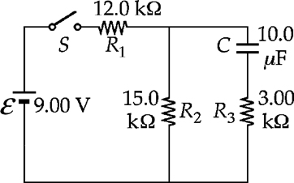

**ANS. FIG. P27.47(b)**

(c) When the switch is opened, the branch containing *R*1 is no longer part of the circuit. The capacitor discharges through (*R*2 + *R*3) with a time constant of

(*R*2 + *R*3)*C* = (15.0 kΩ + 3.00 kΩ)(10.0 *µ*F) = 0.180 s

The initial current *Ii* in this discharge circuit is determined by the initial potential difference across the capacitor applied to (*R*2 + *R*3) in series:



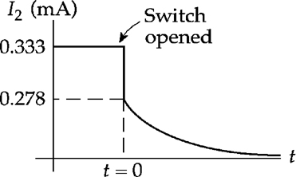

**ANS. FIG. P27.47(c)**

Thus, when the switch is opened, the current through *R*2 changes instantaneously from 333 *µ*A (downward) to 278 *µ*A (downward) as shown in the graph. Thereafter, it decays according to



(d) The charge *q* on the capacitor decays from *Qi* to  according to



**P27.48** From the hint, the equivalent resistance of

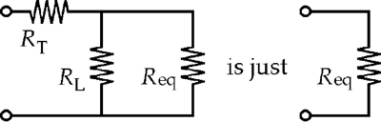

That is, 



Only the + sign is physical:



For example, if *RT* = 1 Ω and *RL* = 20 Ω, then *R*eq = 5 Ω.

**P27.49** (a) For the first measurement, the equivalent  
circuit is as shown in the top panel of ANS.  
FIG. P27.49.

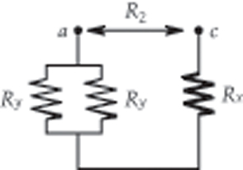

**ANS. FIG. P27.49**

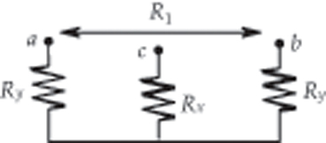



so  **[1]**

For the second measurement, the   
equivalent circuit is shown in the   
bottom panel of ANS. FIG. P28.49.  
Thus,

 **[2]**

Substitute [1] into [2] to obtain:

, or 

(b) If *R*1 = 13.0 Ω and *R*2 = 6.00 Ω, then 

 since this exceeds the limit of 2.00 Ω.

**P27.50** When connected in series, the equivalent resistance is  . Thus, the current is , and the power consumed by the series configuration is



For the parallel connection, the power consumed by each individual resistor is , and the total power consumption is



Therefore,  or 

**Challenge Problems**

**P27.51** Start at the point when the voltage has just reached  and the switch has just closed. The voltage is  and is decaying towards 0 V with a time constant *R*2*C*.

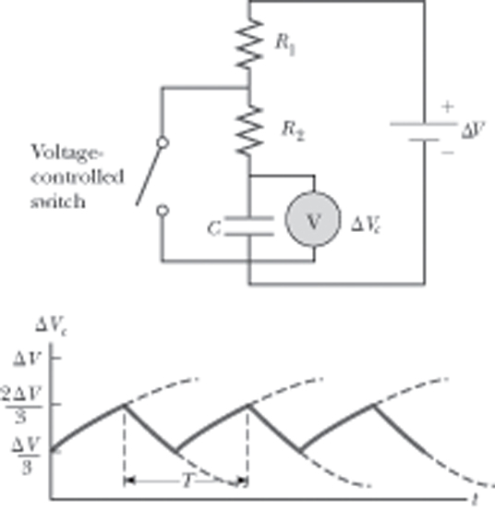

**ANS. FIG. P27.51**



We want to know when  will reach 

Therefore, 





After the switch opens, the voltage is  increasing toward  with time constant (*R*1 + *R*2)*C*:



When 

 or 

so  and 

|  |
| --- |
| **ANSWERS TO QUICK-QUIZZES** |

1. (a)

2. (b)

3. (a)

4. (i) (b) (ii) (a) (iii) (a) (iv) (b)

5. (i) (c) (ii) (d)

|  |
| --- |
| **ANSWERS TO EVEN-NUMBERED PROBLEMS** |

**P27.2** (a) 50%; (b) 0; (c) High efficiency; (d) High power transfer

**P27.4** (a) The 120-V potential difference is applied across the series combination of the two conductors in the extension cord and the light bulb. The potential difference across the light bulb is less than 120 V, and its power is less than 75 W; (b) See ANS. FIG. P27.4; (c) 73.8 W

**P27.6** 15 bulbs

**P27.8** Nichrome: 0.393 m; carbon: 8.98 × 10–3 m

**P27.10** ((a)  (b)  (c) 

**P27.12** None of these is  so the desired resistance cannot be achieved.

**P27.14** (a) See P27.14(a) for the full solution; (b) The current never exceeds   
50 *µ*A.

**P27.16** No, the battery is not being charged.

**P27.18** (a) See ANS. FIG. P27.18; (b) 11.0 mA in the 220-Ω resistor and out of the positive pole of the 5.80-V battery; The current is 1.87 mA in the 150-Ω resistor and out of the negative pole of the 3.10-V battery;   
9.13 mA in the 370-Ω resistor

**P27.20** (a) *I*2 is directed from *b* toward *a* and has a magnitude of 2.00 A;   
(b) *I*3 = 1.00 A; (c) No. Neither of the equations used to find *I*2 and *I*3 contained  and *R*. The third equation that we could generate from Kirchhoff’s rules contains both the unknowns. Therefore, we have only one equation with two unknowns.

**P27.22** (a) ; (b)  (c) ; (d) ; (e)  (f)  and   
*I*1 = 2.88 A; (g) *I*3 = 3.30 A; (h) The negative sign in the answer for *I*2 means that this current flows in the opposite direction to that shown in the circuit diagram and assumed during the solution. That is, the actual current in the middle branch of the circuit flows from right to left and has a magnitude of 0.416 A.

**P27.24** See P27.24 for full explanation

**P27.26** (a) (*R*1 + *R*2)*C*; (b) *R*2*C*; (c) 

**P27.28** 

**P27.30** ((a) For the heater, 12.5 A; For the toaster, 6.25 A; For the grill, 8.33 A; (b) The current draw is greater than 25.0 amps, so this circuit will trip the circuit breaker.

**P28.32** (a) 0.991; (b) 0.648; (c) The energy flows are precisely analogous to the currents in parts (a) and (b). The ceiling has the smallest *R* value of the thermal resistors in parallel, so increasing its thermal resistance will produce the biggest reduction in the total energy flow.

**P27.34** (a) 0.706 A; (b) 2.49 W; (c) Only the circuit in Figure P27.34(c) requires the use of Kirchhoff’s rules for solution. In the other circuits, the 5-Ω and 8-Ω resistors are still in parallel with each other; (c) The power is lowest in Figure P27.34(c). The circuits in Figures P27.34(b) and P27.34(d) have in effect 30-V batteries driving the current.

**P27.36** 55.0 Ω

**P27.38** See P27.38 for full explanation.

**P27.40**  and 

**P27.42** (a)  and ; (b) See P28.66(b) for full proof.

**P27.44** See P27.44 for full explanation.

**P27.46** (a) , where *q* is in microcoulombs and *R* is in ohms; (b) 1.96 *µ*C; (c) Yes; 53.3 Ω; (d) 14.5 *µ*C; (e) Yes. Taking *R* = ∞ corresponds to disconnecting the wire; 0.542 *µ*C

**P27.48** See P27.48 for full explanation.

**P27.50** 